BT DUT Test mode (HM40, USI)
1. Install CAB file (Bluebird BT_TEST.cab)
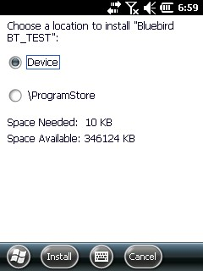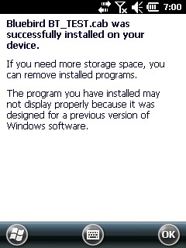

2. RUN Test mode
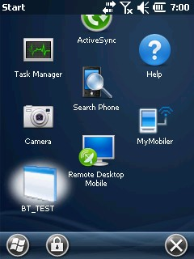

3. Test

